**IS264: Linux II**

Homework 2: Soyinka Chapter 9 (8th ed) 2022

Review the material in the ‘Core System Services’ chapter and then complete the questions below directly in this document. The material to be posted for the question would include (in most cases) a copy of the command you issue plus the system response; on situations where the system response is lengthy, only the first 10-12 lines are all that need to be copied into the document.

 1) What is the system and service manager on our version of Fedora? systemd

How can you verify that on your system? (show the command below).

You can see what version you are running:

[jaycuboss@fedora systemd]$ **systemctl --version**

systemd 249 (v249.9-1.fc35)



You can view the contents of the directories systemd uses:

[jaycuboss@fedora systemd]$ **cd /etc/systemd/**

[jaycuboss@fedora systemd]$ **ls**

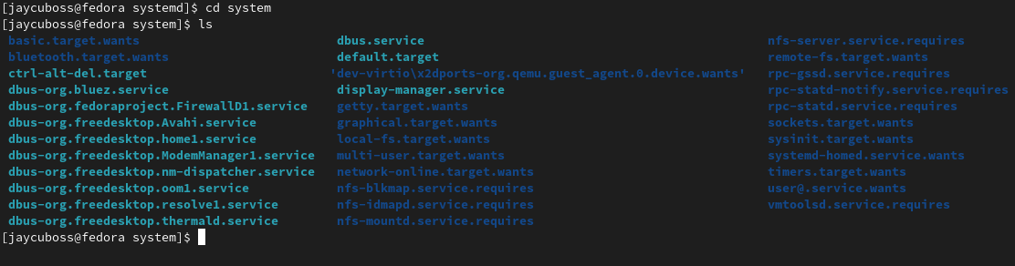

What version of Linux is running on fawad, and what is it’s system manager? (show commands below that answer the questions – with output included).

[jhaas40@fpfawad ~]$ uname -a

Linux fpfawad **3.10.0-1127.19.1.el7.x86_64** #1 SMP Tue Aug 11 19:12:04 EDT 2020 x86_64 x86_64 x86_64 GNU/Linux

 2) Investigate the units active on your system (units are described in the Soyinka chapter).  Copy and paste here the results of commands to show the units for target, mount, and socket types.  You only need to include the first 10 lines or so of each unit result.  
  
3) Indicate the commands to turn off and then disable the Fedora firewall service, as well as the command to temporarily disable SE Linux (during a log-on session). Issue all these commands on your system. What commands should you then issue to verify that all steps were successful? (copy in the results of the verification commands to this document)

[root@fedora network-scripts]# **systemctl stop firewalld**

[root@fedora network-scripts]# **systemctl disable firewalld**

[root@fedora network-scripts]# **systemctl status firewalld**

○ firewalld.service - firewalld - dynamic firewall daemon

Loaded: loaded (/usr/lib/systemd/system/firewalld.service; disabled; vendor preset: enabled)

Active: inactive (dead)

Docs: man:firewalld(1)

[root@fedora network-scripts]# **setenforce 0**

[root@fedora network-scripts]# **getenforce**

Permissive  
  
4) Install xinetd as discussed in the text and perform the echo service example in the text.

[jhaas40@fedora Downloads]$ sudo rpm -i xinetd*.rpm

[sudo] password for jhaas40:

warning: xinetd-2.3.15-34.fc33.x86_64.rpm: Header V4 RSA/SHA256 Signature, key ID 9570ff31: NOKEY

package xinetd-2:2.3.15-34.fc33.x86_64 is already installed

Issue the command "telnet localhost 7" prior to completing work on the Echo service; copy and paste the screen response here to show the result.

[root@fedora Downloads]# telnet localhost 7

bash: telnet: command not found...

Install package 'telnet' to provide command 'telnet'? [N/y] y

[root@fedora Downloads]# telnet localhost 7

Trying ::1...

telnet: connect to address ::1: Connection refused

Trying 127.0.0.1...

telnet: connect to address 127.0.0.1: Connection refused

Then complete the echo-stream service steps as discussed in the text and show the result of the "telnet localhost 7" command (copy and paste the system response). (Note that the way to terminate the process once in telnet is to type ctrl-] and then type the command 'quit')

[root@fedora Downloads]# cd /etc/xinetd.d/

[root@fedora xinetd.d]# ls

chargen-dgram chargen-stream daytime-dgram daytime-stream discard-dgram discard-stream echo-dgram echo-stream tcpmux-server time-dgram time-stream

[root@fedora xinetd.d]# vi echo-stream

[root@fedora xinetd.d]# systemctl restart xinetd

[root@fedora xinetd.d]# telnet localhost 7

Trying ::1...

Connected to localhost.

Escape character is '^]'.

Hello Jacob

Hello Jacob

hiya

hiya

yo

yo

b

b

abc

abc

def

def

ghi

ghi

jkl

jkl

^

^

^]

telnet> quit

Connection closed.

   
5) Examining system startup messages (syslog) in versions prior to Fedora 20 was based on a utility called rsyslog.  However, current Fedora versions no longer have rsyslog installed by default, and instead use a utility called journalctl.   To compare the two utility processes, do the following:  
  
      a) after a reboot, run the "journalctl" and "journalctl -f" commands and copy 10 lines from each into the document  
  
      b) reinstall rsyslog and follow the text instructions regarding the change to the rsyslog.conf file to direct Kernel messages to a file called /var/log/kernmessages.  Reboot your system and copy/paste the top 10 lines of the new kernmessages file to your assignment document (see Soyinka for details).  
  
      c) use your results from step b to build a grep of the journalctl output to try to locate the same information in the journal as you had from rsyslog.  Copy/paste the results here.

6) After reviewing the information in the crontab section of the text, install the ‘cronie’ package on your Fedora system and then edit your user's crontab file (not the root user’s file). Have it send 3 pings to yahoo.com every 2 minutes; have the result of the pings *add* to a file called yahooping in your user home directory.  Below, show the command you added to crontab and include a copy of your yahooping file after at least 2 cycles (i.e., 4 minutes).  
 **Chapter 9 – read through crontab material and follow these instructions**  
Important: after you have accomplished the crontab step, please *remove* your crontab entry so that it does not continue to ping!

**Command: */2 * * * * ping -c 3 yahoo.com >> ~/yahooping**

[jhaas40@fedora ~]$ more yahooping

PING yahoo.com (74.6.143.26) 56(84) bytes of data.

64 bytes from media-router-fp74.prod.media.vip.bf1.yahoo.com (74.6.143.26): icmp_seq=1 ttl=45 time=33.3 ms

64 bytes from media-router-fp74.prod.media.vip.bf1.yahoo.com (74.6.143.26): icmp_seq=2 ttl=45 time=33.3 ms

64 bytes from media-router-fp74.prod.media.vip.bf1.yahoo.com (74.6.143.26): icmp_seq=3 ttl=45 time=33.5 ms

--- yahoo.com ping statistics ---

3 packets transmitted, 3 received, 0% packet loss, time 2004ms

rtt min/avg/max/mdev = 33.293/33.369/33.467/0.072 ms

PING yahoo.com (74.6.231.20) 56(84) bytes of data.

64 bytes from media-router-fp73.prod.media.vip.ne1.yahoo.com (74.6.231.20): icmp_seq=1 ttl=47 time=33.8 ms

64 bytes from media-router-fp73.prod.media.vip.ne1.yahoo.com (74.6.231.20): icmp_seq=2 ttl=47 time=31.7 ms

64 bytes from media-router-fp73.prod.media.vip.ne1.yahoo.com (74.6.231.20): icmp_seq=3 ttl=47 time=33.8 ms

--- yahoo.com ping statistics ---

3 packets transmitted, 3 received, 0% packet loss, time 2003ms

rtt min/avg/max/mdev = 31.738/33.134/33.839/0.987 ms

PING yahoo.com (98.137.11.164) 56(84) bytes of data.

64 bytes from media-router-fp73.prod.media.vip.gq1.yahoo.com (98.137.11.164): icmp_seq=1 ttl=46 time=69.6 ms

64 bytes from media-router-fp73.prod.media.vip.gq1.yahoo.com (98.137.11.164): icmp_seq=2 ttl=46 time=69.7 ms

64 bytes from media-router-fp73.prod.media.vip.gq1.yahoo.com (98.137.11.164): icmp_seq=3 ttl=46 time=69.7 ms

--- yahoo.com ping statistics ---

3 packets transmitted, 3 received, 0% packet loss, time 2003ms

rtt min/avg/max/mdev = 69.551/69.665/69.749/0.083 ms

Submit your completed document by clicking on the assignment title which is a link to an upload page: paste your document and submit.